**ISEM 3006 Data Management in Business**

**Exercise 5**

**SQL SELECT Answers**

**Use the Trustful Property Rental Company Database in Exercise 3.**

**Use PostgreSQL SELECT statement to answer the following queries.**

**Unless state otherwise, the case of strings is important, i.e. if I ask you to retrieve properties that are located in 'KLN', you only retrieve properties that are located in 'KLN', but not 'kln', 'Kln', 'kLn', etc.**

1. For each of the employee who is in charge of properties, list his/her name, employeeID, and the total number of viewings of all the properties for which he/she is in charge of. Only list those employees that has total number of viewings greater than 6.

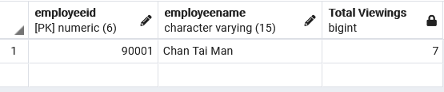

SELECT EmployeeID, EmployeeName, COUNT(EmployeeID) AS ‘Total Viewing’

FROM Employee E

JOIN Property P

ON E.EmployeeID = P.EmployeeID

JOIN Viewing V

ON V.PropertyNo = P.PropertyNo

GROUP BY E.EmployeeID

HAVING COUNT(E.EmployeeID) > 6 ;

1. List the owner number and name of the property owners who have listed ‘Flat’ located in the city ‘KLN’ BUT HAVE NOT listed ‘Flat’ located in the city ‘HK’.

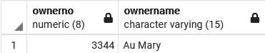

SELECT DISTINCT PO.ownerno, PO.ownername

FROM PropertyOwner PO

JOIN Property P

ON P.OwnerNo = PO.OwnerNo

WHERE P.PropertyCity LIKE ‘KLN’

AND

P.Type LIKE ‘Flat’

EXCEPT

SELECT DISTINCT PO.ownerno, PO.ownername

FROM PropertyOwner PO

JOIN Property P

ON P.OwnerNo = PO.OwnerNo

WHERE P.PropertyCity LIKE ‘HK’

AND

P.Type LIKE ‘Flat’ ;

1. List the property number, ownerno, monthly rental, and the name of the ‘in-charge’ employee for those property having a monthly rental less than the average of the monthly rental of all the properties.

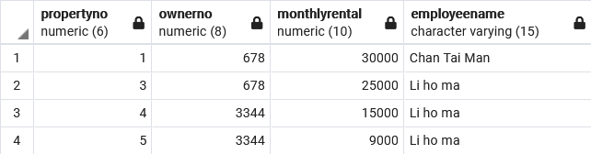

SELECT P.propertyno, P.ownerno, P.MonthlyRental, P.EmployeeName

FROM Employee E

JOIN Property P

ON E.EmployeeID = P.EmployeeID

WHERE P.MonthlyRental < (SELECT AVG(MonthlyRental) FROM Property) ;

1. For properties that have viewing, list the property no, property street, and the number of viewings it has. Only list those properties that have the number of viewings that is more than number of viewings of the property with propertyno = 4.

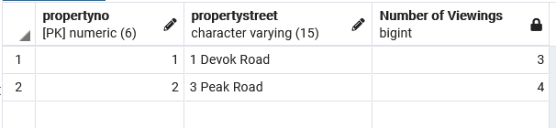

SELECT P.propertyno, P.ProperyStreet, COUNT(P.PropertyNo) AS ‘number of viewings‘

FROM Property P

JOIN Viewing V

ON V.PropertyNo = P.PropertyNo

GROUP BY P.PropertyNo

HAVING COUNT(P.PropertyNo) <(SELECT COUNT(V.PropertyNo) FROM Viewing V WHERE V.propertyno = 4) ;

1. List the Employee ID and the name of the employees who have not been in charge of any property.
   1. using outer join
   2. using EXCEPT (set operation)
   3. using subquery (DON"T use OUTER JOIN or EXCEPT in this answer)

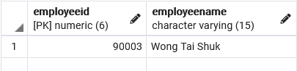

a)

SELECT DISTINCT EmployeeID, EmployeeName

FROM Employee E

RIGHT JOIN Property P

ON E.EmployeeID = P.EmployeeID

WHERE E.EmployeeID IS NULL ;

b)

SELECT DISTINCT EmployeeID, EmployeeName

FROM Employee

EXCEPT

SELECT DISTINCT EmployeeID, EmployeeName

FROM Employee E

RIGHT JOIN Property P

ON E.EmployeeID = P.EmployeeID

c)

SELECT EmployeeID, EmployeeName

FROM Employee

WHERE EmployeeID NOT IN (SELECT DISTINCT EmployeeID FROM Property);

1. List the client number, client name, and the number of properties that he/she have viewed for those clients who have viewed ALL the properties. (Note a client may view the same property many time.)

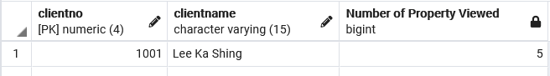

SELECT ClientNo, ClientName, AS ‘number of properties viewed’

FROM Employee

1. List the client number, client name, and the number of properties that he/she have viewed for those clients who have viewed ALL the properties located in the city ‘HK’. (Note a client may view the same property many time.)

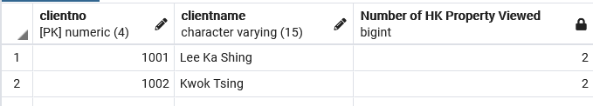

1. List the owner name, property number, property street address, and the monthly rental for the 2 properties which have the highest monthly rental. You should take care of ties, i.e., if a property has the monthly rental as the 2nd property, it should also be included in the result. Order the output by monthly rental in descending order. (Even though there is no tie in this particular set of data, your answer need to take care of the tie.)

